User Based Login Process – Data.Comreg.ie

User
- Click Activate Account button in the email received.
- Enter a new password which must be at least 7 characters long, contain at least one number and one special character.
If you are having issues setting your new password it may be down to browser caching. Please Ctrl + F5/or delete the cache and try again.
- Login – Please log in using your Email Address and Password 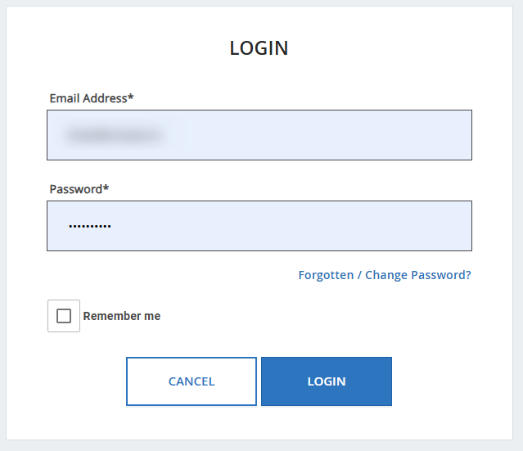

- Click Login, you will then be presented with a screen to set up Multi Factor Authentication.
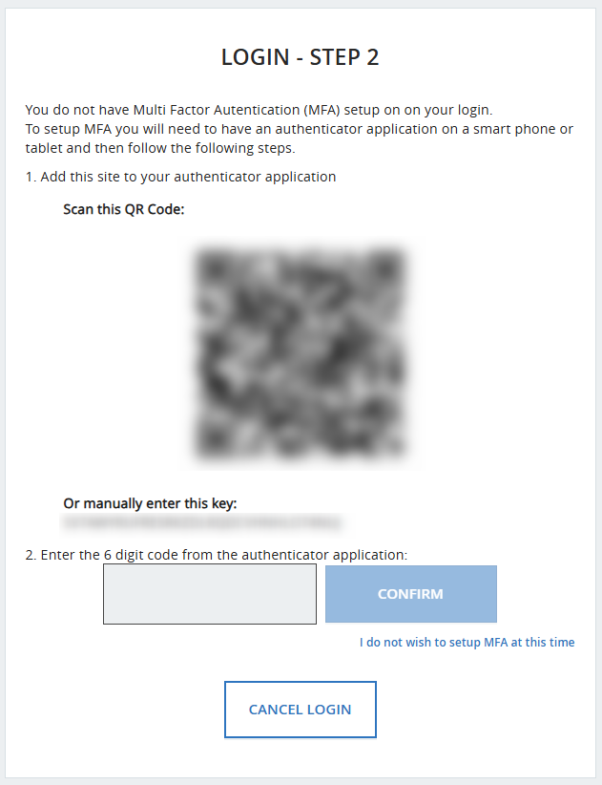
- Scan the QR code with an authenticator app of your choice (this works with all the usual authenticator apps e.g. Google, Microsoft, Cisco Duo), the app will then provide a 6-digit code which you enter and click confirm.
On subsequent logins they will only be prompted for the 6-digit code from the app, i.e. MFA is set up once and your app will display the code for future logins.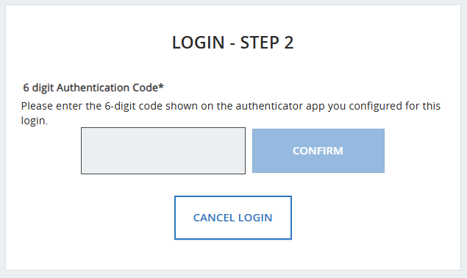
Once the 6-digit code is entered (in either case) you will be brought to the existing landing page.

User is on Multiple Accounts
If you have more than one account associated with your login email address, you will be presented with a filterable list that allows you to select the account you wish to use.

